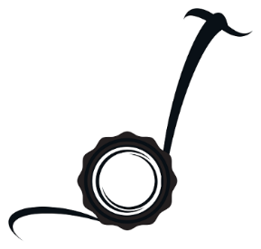
Eco-Glide.com™
Office: 682-267-6300

How to download APP：PT60-X, PT60-X2
IOS/Apple: Enter “App Store”, search “Eco-Glide”, and you can download APP on the Apple Store
Android: Please scan the QR code below. You will need to download the apk file and install the apk file. Note: You will also need to allow “install from unknown sources”.
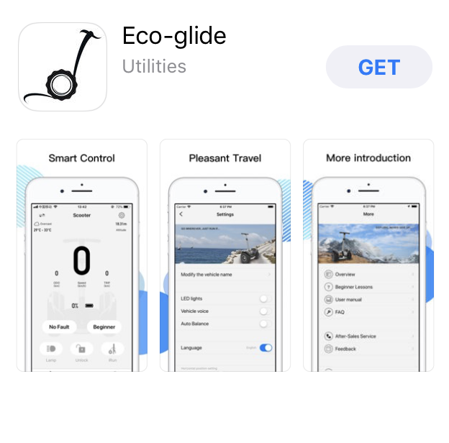
Note: You will need to download a Free QR code reader from the Google play store to scan the image to start the download.

App Use Instruction: Turn on Machine with Power button under flap next to lower Screen.
Open App by clicking on Icon on your phone:
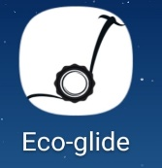
Click Double Arrow
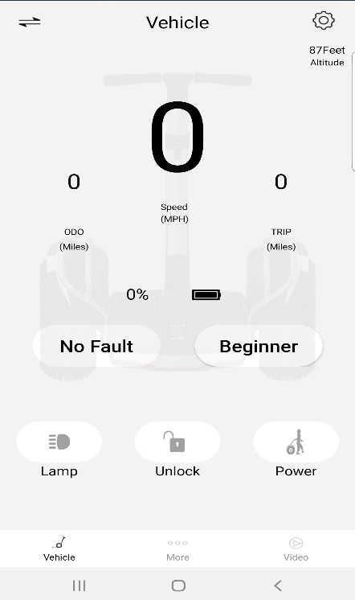
Note Serial Number
After clicking double arrow, you will find the phone searching for the machine. If you see:
Tv231u-FFD2CA22, Click on this button to connect to machine.
Note: This is your serial number. Please write it down.

.
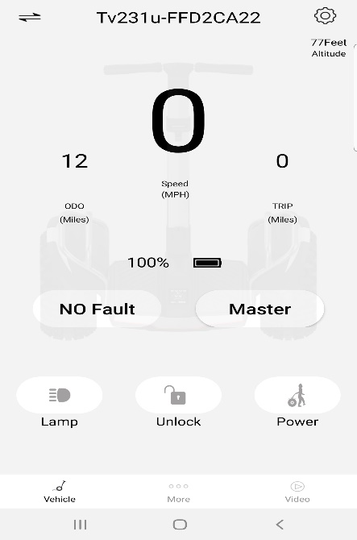
Once Connected you will see your serial number for your machine.
You will also see Battery Status.
If you see “Vehicle” you’re not connected please repeat the first 2 steps.

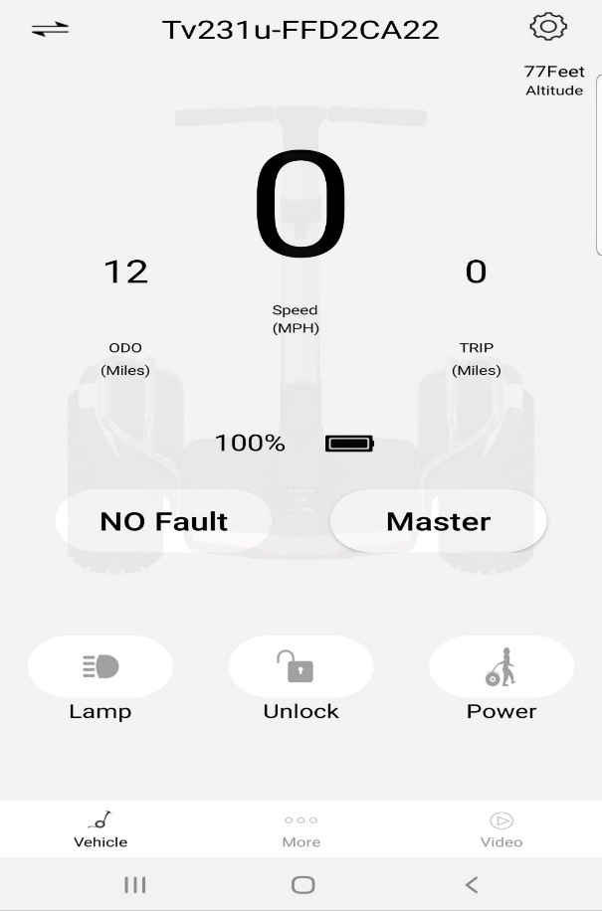
Towing Mode for steep hills etc.: This provides power to the machine so you can walk next to the machine with your hand on the steering bar and guide the machine up or down a steep hill. Note: Make sure to turn off when not using.
Towing Mode
NO Fault=Safe to Ride
Odometer
Front Headlight
Master /Beginner Mode Button

Unlock Button: This is to unlock/lock the platform of the machine. If in the lock position, the machine will not engage the motors. Note: Machine power switch must be on to activate or deactivate.

Settings Mode Button
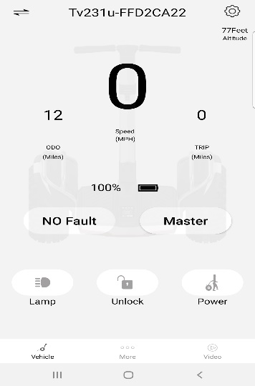
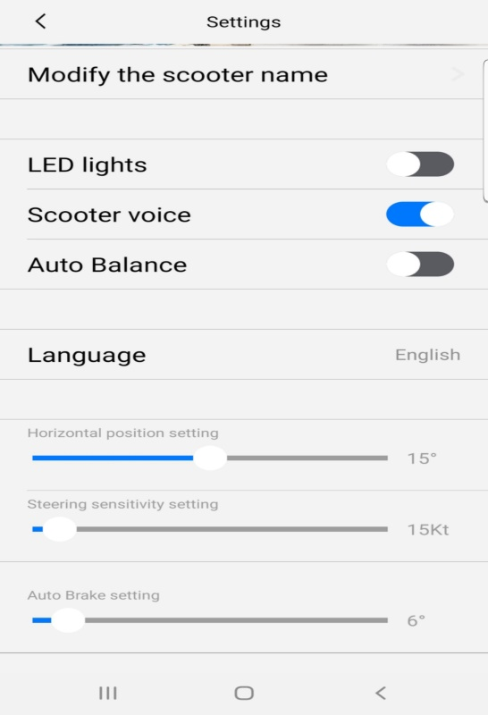
Autobrake lean back adjustment
Steering Bar sensitivity
Position of the Footpad to the ground
“Auto Balance” should always be off before you ride the unit.
Auto Balance is for parking only
LED button is for Running lights

Note: You will need to adjust the settings of “Steering Sensitivity” and “Auto Brake” before use with the settings in the picture above. Use these exact settings. You will need to change the settings when you switch between “Beginner” and “Master” mode. Once you get used to the steering sensitivity, you can raise the bar to your desired sensitivity level.
Reminders: The App will auto reconnect if it is left on in the background of your phone.
If you close the App in the background, you will need to reconnect each time.
Safety: Always wear protective gear and never attempt a very steep grade or descent. This is what “Power” or Tow mode is for. Also, never try to steer the machine aggressively while you’re riding at higher speeds.

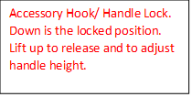
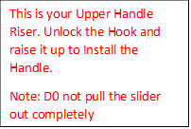
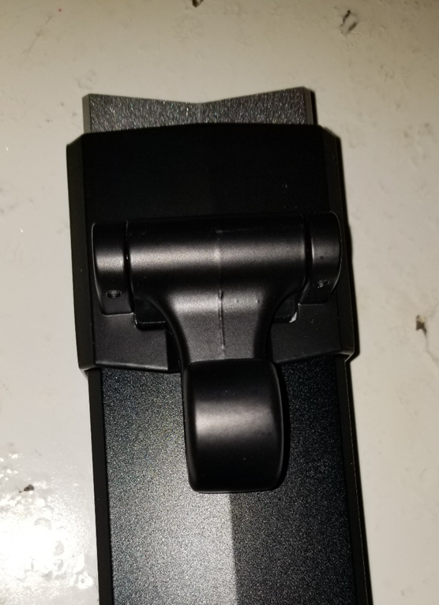
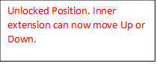
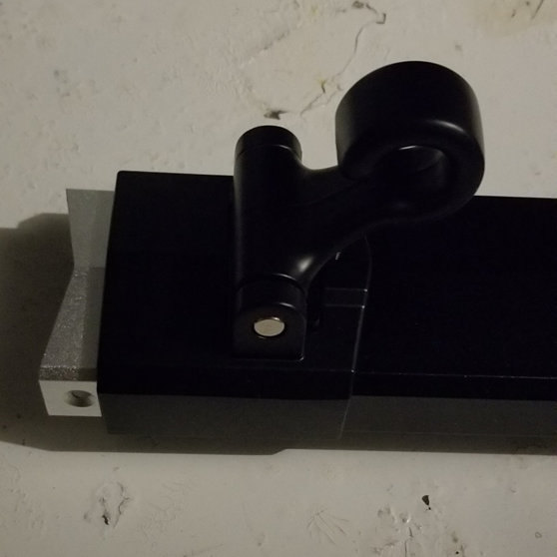
Bluetooth Music Function
- Make sure your Bluetooth is on within your phone settings.
- Turn your machine on with the Power Button under the flip down cap.
- Open your Bluetooth settings on your phone and search for new devices.
- Look for ODWYMUSIC on your phone and connect to it.
- Your machine will tell you out loud that it is “now connected to the Bluetooth”.
- Use your favorite streaming service to listen to music with the provided speaker.
- Use your phones volume control to adjust unit’s volume.

Happy Gliding,
The Eco-Glide Team
Note: For Assistance, please email Info@eco-glide.com

